**Alternative Self-Improvement**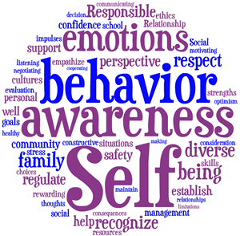

**2019/2020**

|  |
| --- |
| Teacher: Mrs. Tehann Zelinski |
| Pronouns: She/Her |
| Phone: 763-506-8446 |
| Email: tehann.zelinski@ahschools.us |

**Course Description/Overview**

Alternative Self-Improvement will focus on the personal growth and development of each learner within the class. The class will include targeted lessons and units to support the social and emotional growth of each learner. Topics to be covered will include growth mindset, character education, self-awareness, stress management, mindfulness, healthy relationships, and emotional regulation. Additional lessons will be integrated to address present student needs and identified IEP need areas.

**Curriculum Resources and Instructional Methods**

The Alternative Self-Improvement class will utilize a variety of resources to support student learning. This will include handouts, videos, news articles, and books. Students will engage in social/emotional learning through various means including guided independent tasks and reflection, group discussions, student conferences, and group activities.

**Materials**  
- Notebook/Folder (students will store in the classroom unless sent home for practice)  
- Pencil/Pen

**Typical Day**

* Bell Ringer - Journaling
* Mindfulness Activity
* Unit Lesson and/or Activity
* Individual Homework Time

**Grading**

Grading will be based on progress made towards learning targets and data will be collected on a daily tracking sheet.

**10% Formative (weekly reflections/goal sheet) / 90% Summative (daily point sheet)**

**In Class Practice**

Practice = Progress! In Alternative Self-Improvement, you need to practice skills to make progress. Students will be given opportunities through group structured activities, discussions, individual assignments/tasks, and individual reflections to practice skills on a daily and weekly basis. Most practice will be completed within the classroom; however, out-of-class practice may be assigned to extend learning opportunities.

**Missing & Late Work**   
**Formative Work:** Formative points account for 10% of your grade in this class. At the end of the week, students will engage in reflection and practice activities related to the topics discussed during the week, which will count towards your formative score. If you are absent for a day, you may be assigned an alternative activity to earn back missing points; activities could include watching a video and writing a reflection, before school/after school work time, a worksheet, or reading an article.

**Summative Work:** Summative points account for 90% of your grade in this class. Students will be graded daily using a point sheet, with 10 points earned per day. Weekly points will then be entered as a percentage into Synergy. If you are absent for a day, you may be assigned an alternative activity to earn back missing points; activities could include watching a video and writing a reflection, before school/after school work time, a worksheet, or reading an article.

**Re-Learning/Re-Assessment**  
I am in support of students engaging in re-learning/re-assessments. No grade is final if you are willing to extend your learning. If you are absent for a day, you may be assigned an alternative activity to earn back missing points; activities could include watching a video and writing a reflection, before school/after school work time, a worksheet, or reading an article. 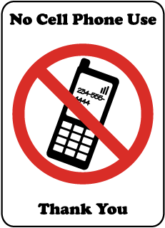

**Cell Phones/Electronic Devices:**Students need to “disconnect” from their devices for the period. Tech devices should be out of sight during class.

**Classroom Routine:**

We will start class promptly and I want you there!!!. You are expected to be on-time to class and if you are late, you will be marked tardy. Reoccurring tardies will result in intervention, which could include a student conference, conferencing with an administrators, and/or parent/guardian contact. Be on-time, be prepared, and be ready to have fun!

Please sign below to acknowledge you have reviewed the policies of Alt Self-Improvement.

Student name ________________________ Student Signature ______________________ 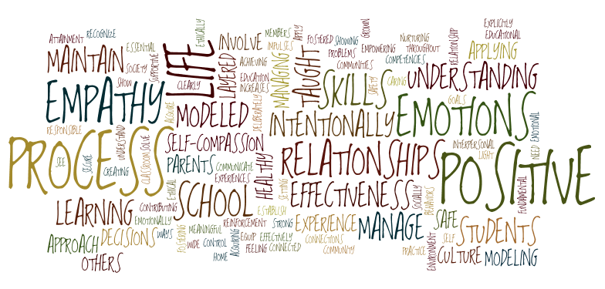

*Image from https://www.redclayschools.com/Page/1901 and https://www.pisd.edu/domain/9513